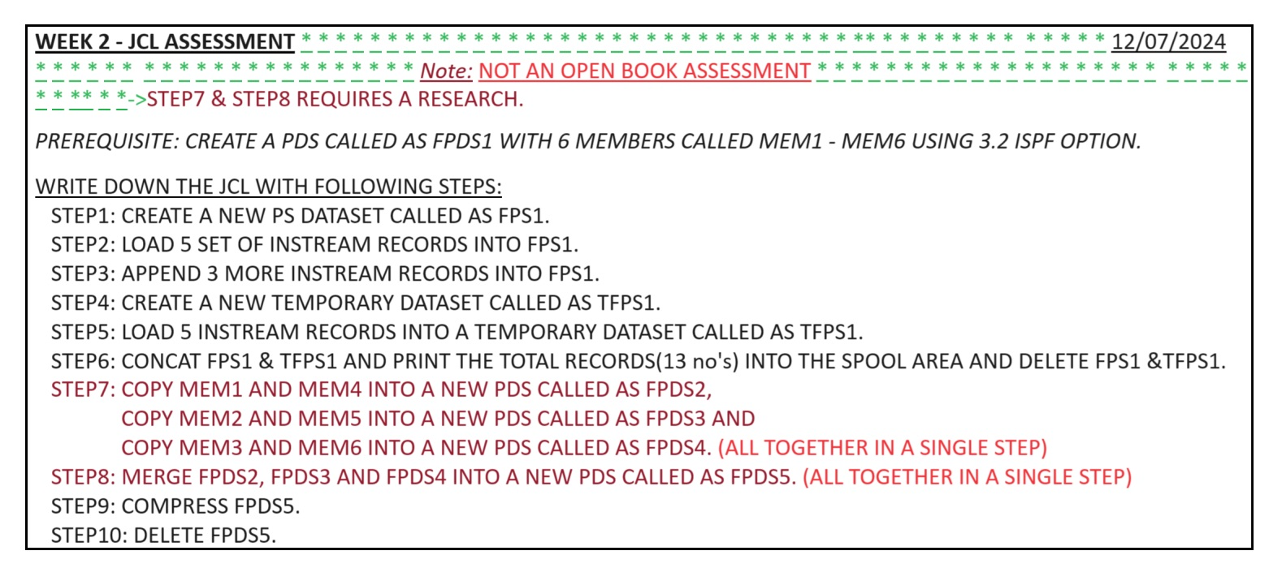

WEEK 2-JCL ASSESSMENT\*\*\*\*\*\*

\*\*\*\*\*\*Note: NOT AN OPEN BOOK ASSESSMENT \*\*\*\*

12/07/2024

\*\*\*\*\*\*->STEP7 & STEP8 REQUIRES A RESEARCH.

PREREQUISITE: CREATE A PDS CALLED AS FPDS1 WITH 6 MEMBERS CALLED MEM1 - MEM6 USING 3.2 ISPF OPTION.

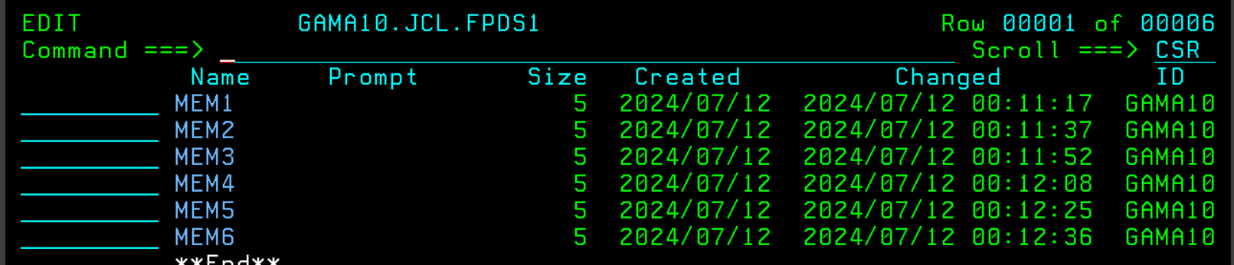

WRITE DOWN THE JCL WITH FOLLOWING STEPS:

STEP1: CREATE A NEW PS DATASET CALLED AS FPS1.

Created job card and job statements.

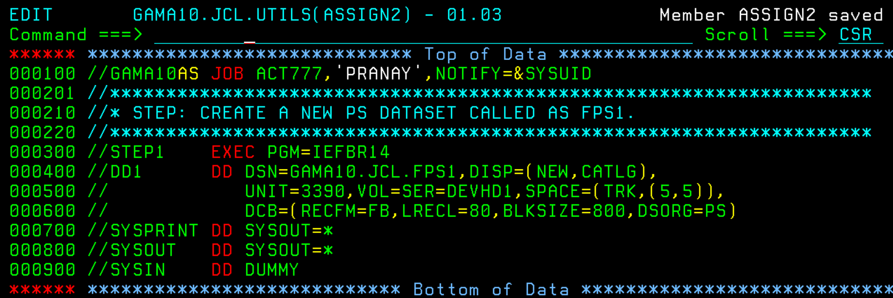

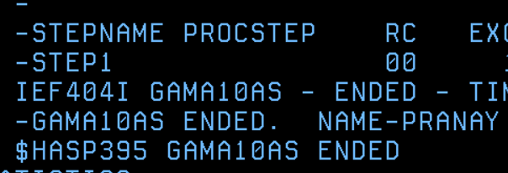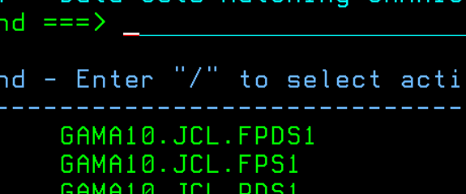

STEP2: LOAD 5 SET OF INSTREAM RECORDS INTO FPS1.

Used Restart=Step2 in the job card along with the step2 job statements.

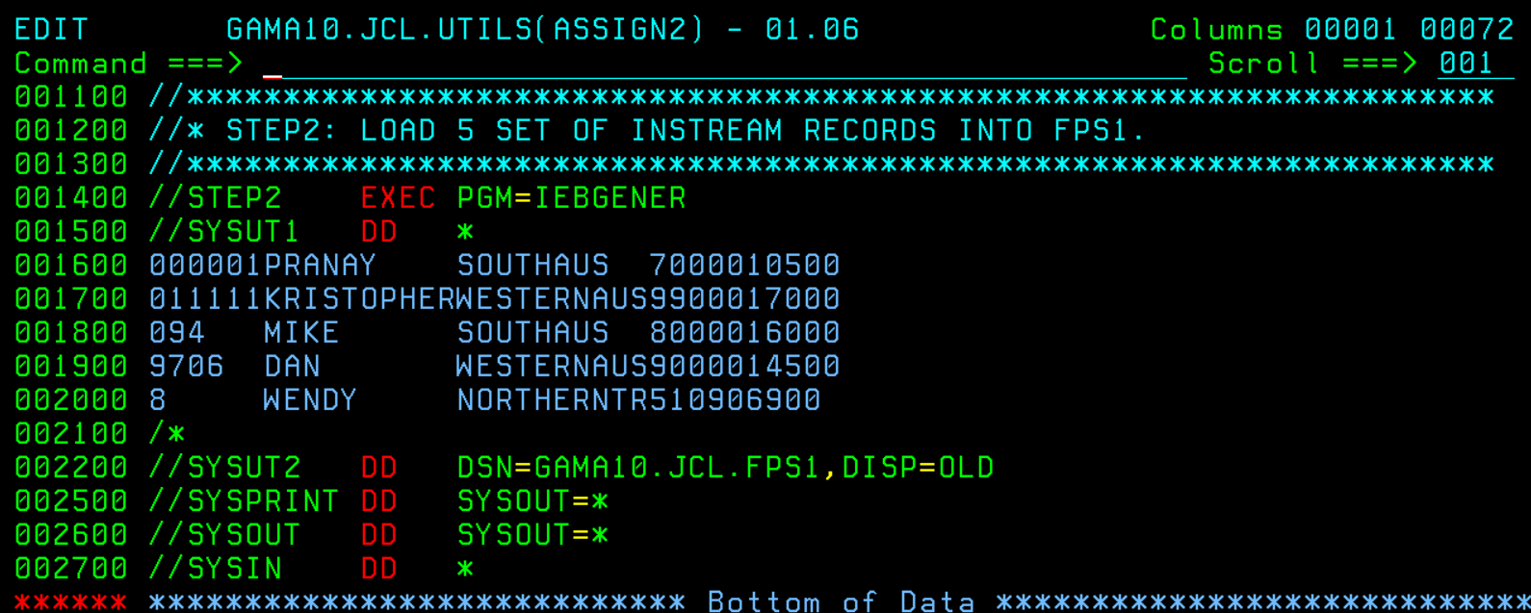

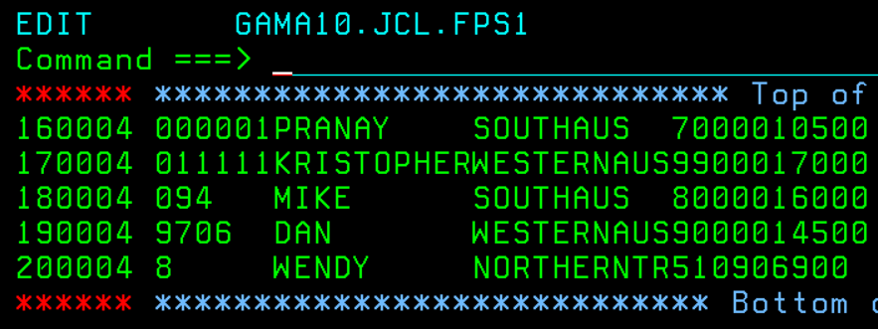

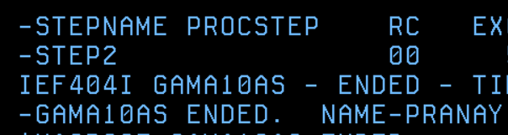

STEP3: APPEND 3 MORE INSTREAM RECORDS INTO FPS1.

Used DISP=MOD to append 3 more lines of instream records.

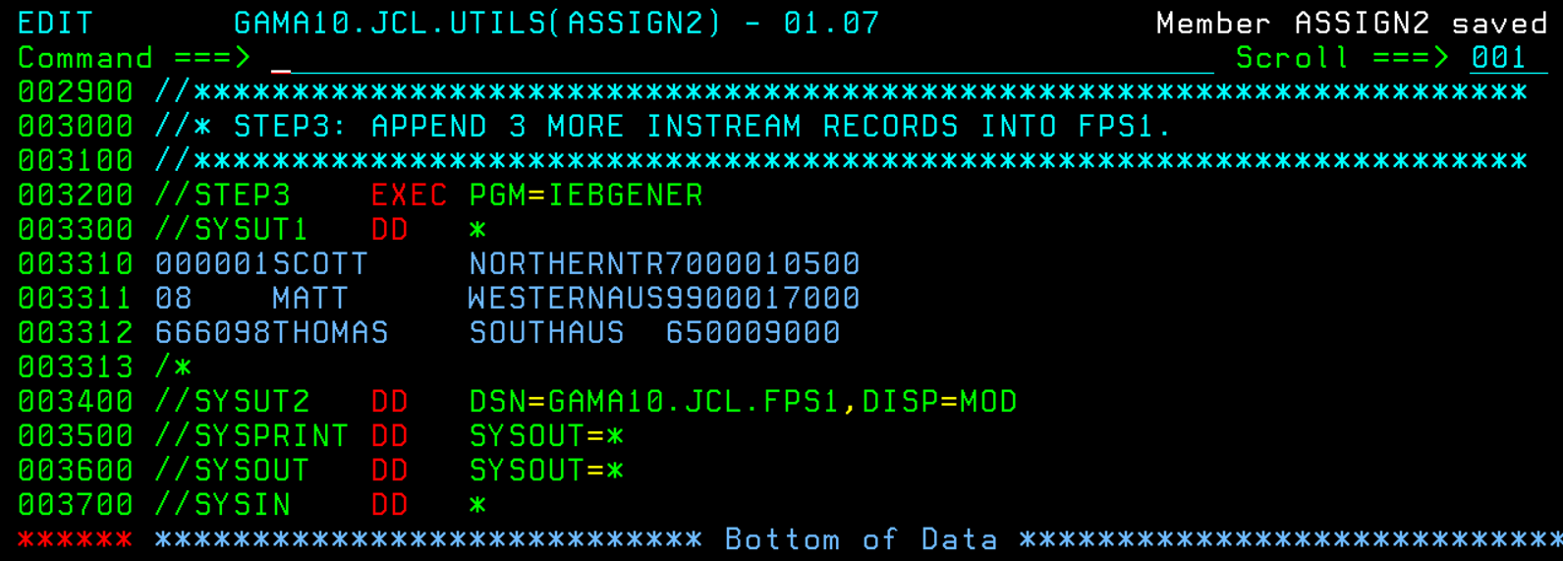

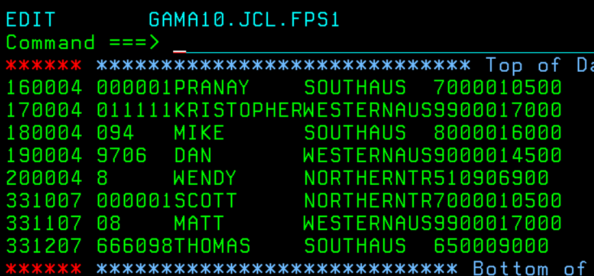

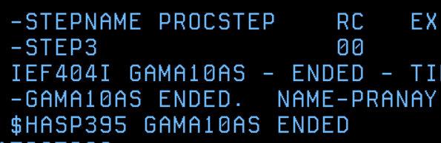

STEP4: CREATE A NEW TEMPORARY DATASET CALLED AS TFPS1.

Used PASS in disp and also && for file path.

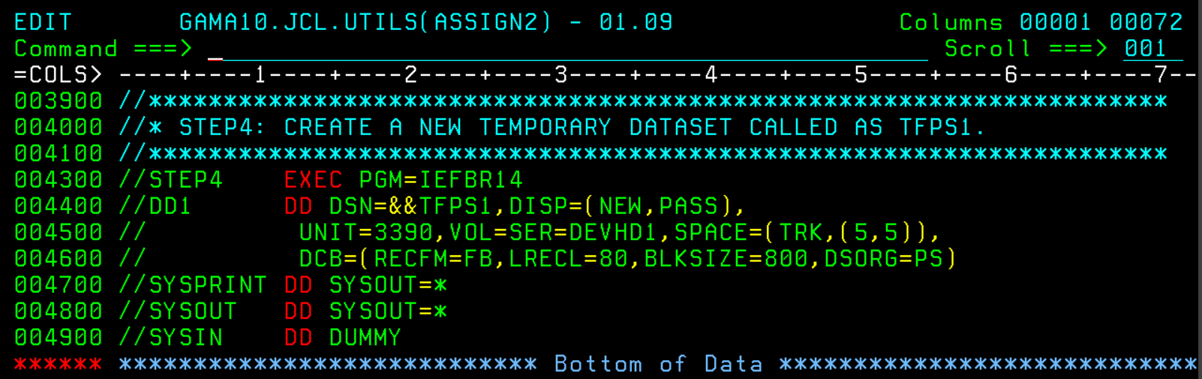

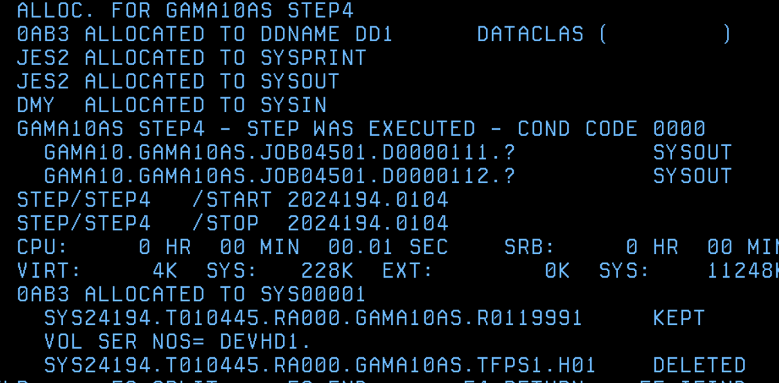

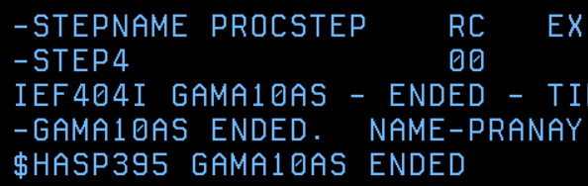

STEP5: LOAD 5 INSTREAM RECORDS INTO A TEMPORARY DATASET CALLED AS TFPS1.

Used DISP=(MOD,PASS) and restarted from step4.

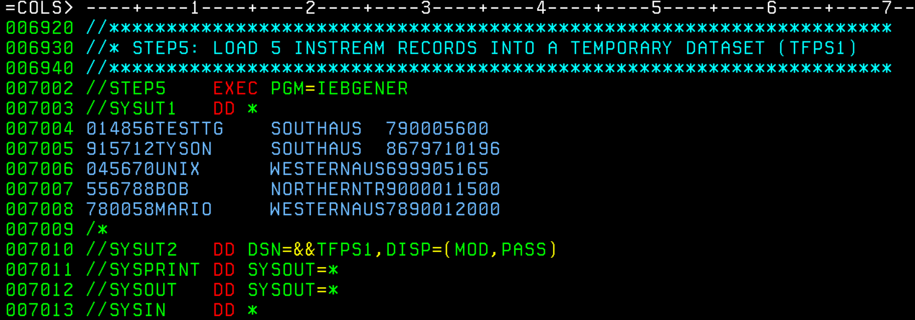

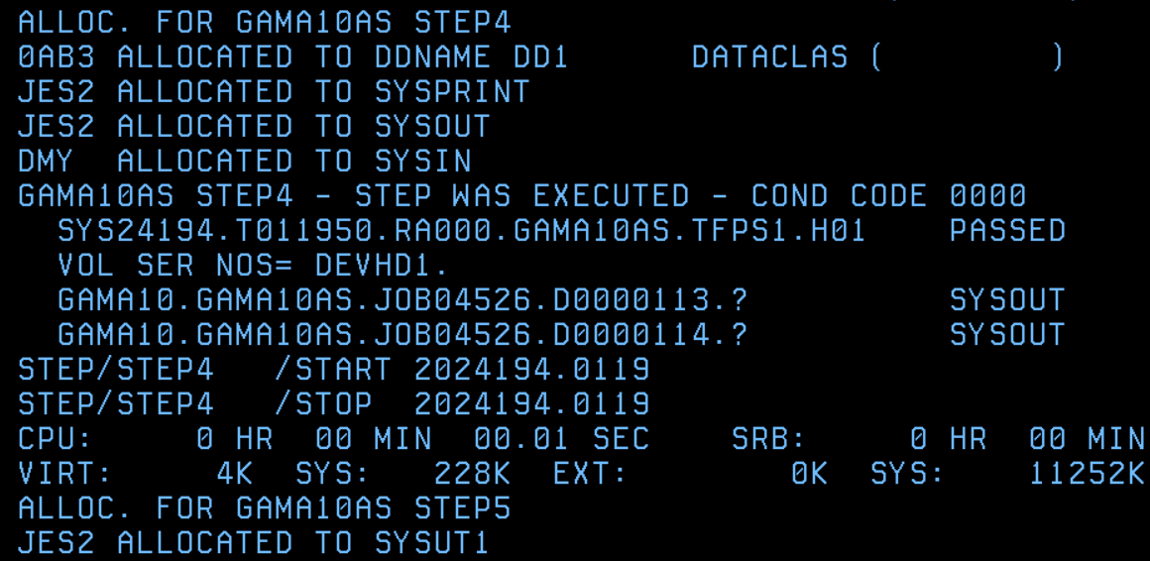

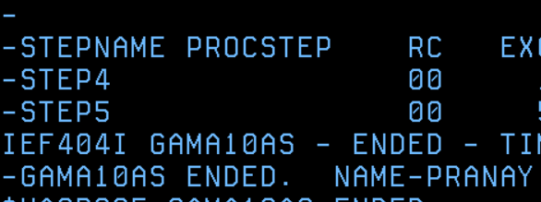

STEP6: CONCAT FPS1 & TFPS1 AND PRINT THE TOTAL RECORDS(13 no's) INTO THE SPOOL AREA AND DELETE FPS1 &TFPS1.

Used two datasets in one SYSUT1, then delete in disp and made sysut2 as sysout=\* to output to the spool. I faced a JCL error due to the wrong step name which made my fps1 file get deleted. So, I removed the restart parameter from the job card to start from step1.

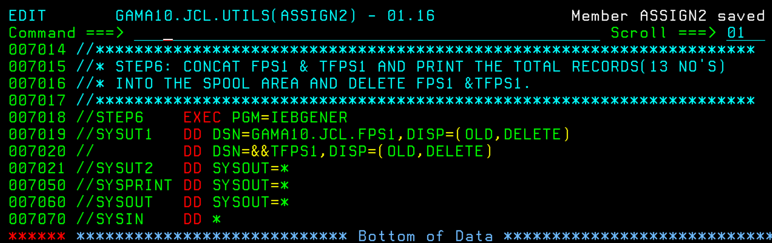

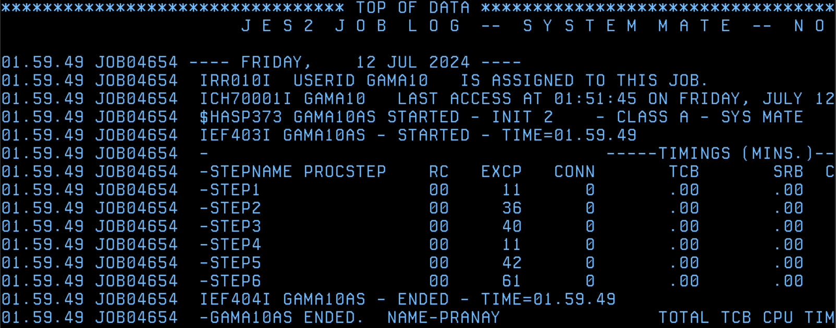

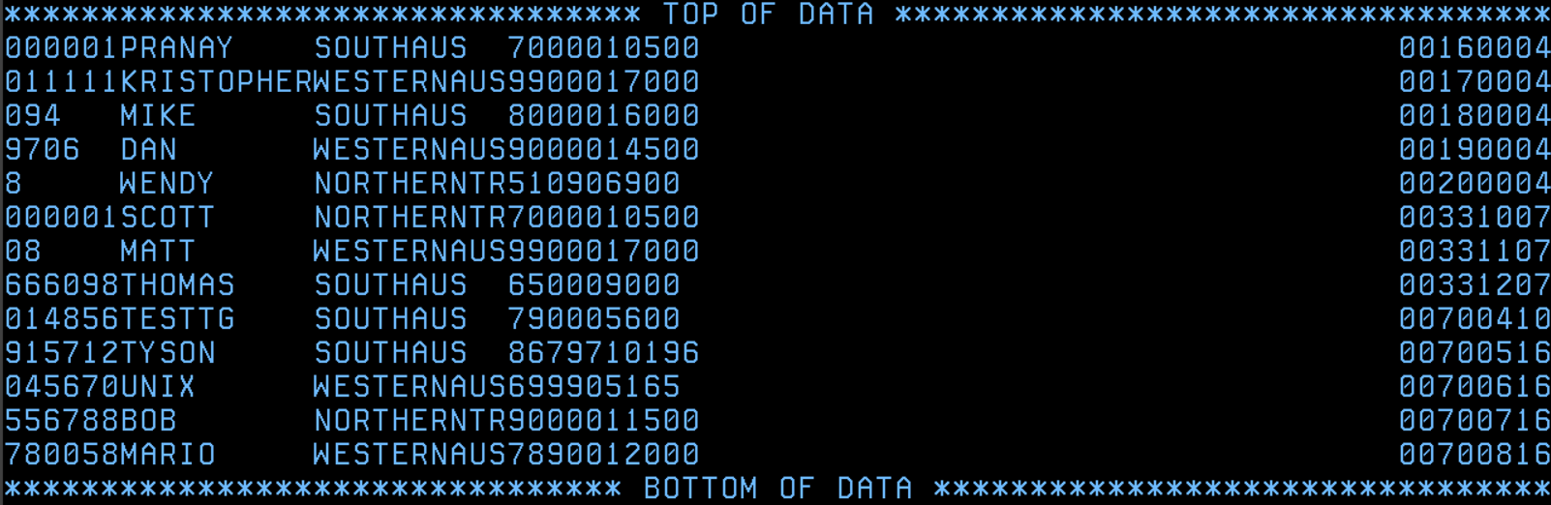

STEP7: COPY MEM1 AND MEM4 INTO A NEW PDS CALLED AS FPDS2, COPY MEM2 AND MEMS INTO A NEW PDS CALLED AS FPDS3 AND COPY MEM3 AND MEM6 INTO A NEW PDS CALLED AS FPDS4. (ALL TOGETHER IN A SINGLE STEP)

Much research wasn’t needed as my first thought from reading the question was if I can use multiple copy commands because I knew we can use multiple datasets with DD. There was no need for SYSUT in this because it's IEBCOPY. So, I just researched if multiple COPY statements in scratchpad are allowed and after finding out they are, I coded. Also, I used the restart parameter in the job card from step7 because steps1-6 were not needed for this step.   
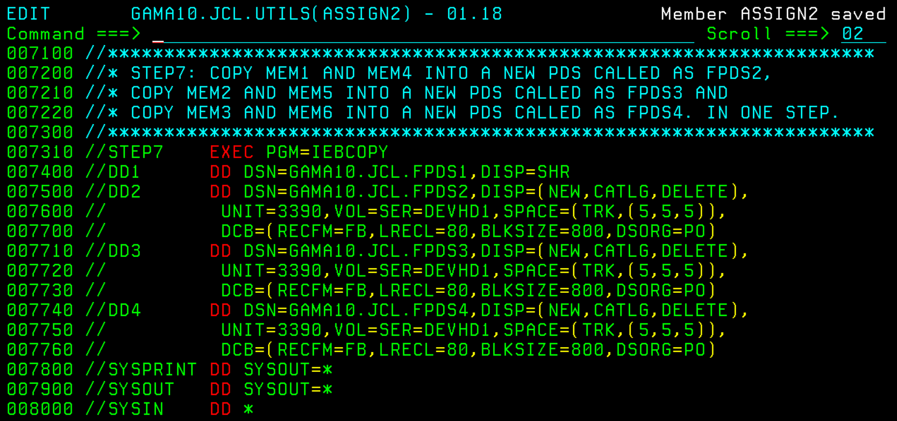

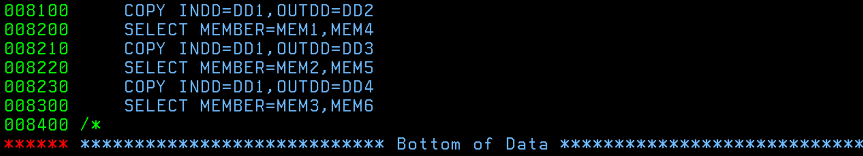

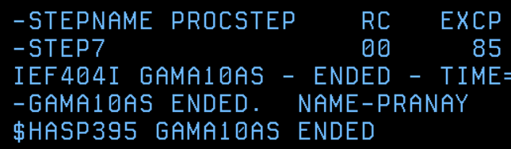

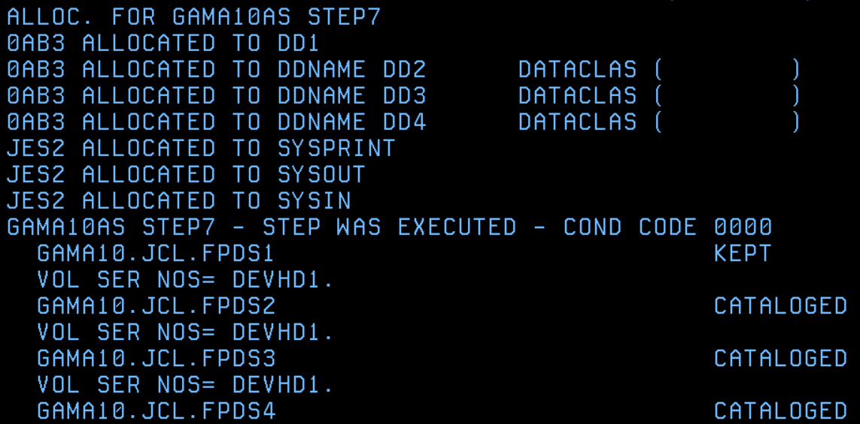

STEP8: MERGE FPDS2, FPDS3 AND FPDS4 INTO A NEW PDS CALLED AS FPDS5. (ALL TOGETHER IN A SINGLE STEP)

For this step I first thought of there being a merge command, but as I researched I found that we can simply use: indd=(mem1,mem2,mem3) outdd=mem4. Restart parameter was step8. Also, I used delete for DD1-DD3 in disp because we are merging. They have to be removed from their old spot. So, if we don't use delete there will still be a copy of those in the catalog.

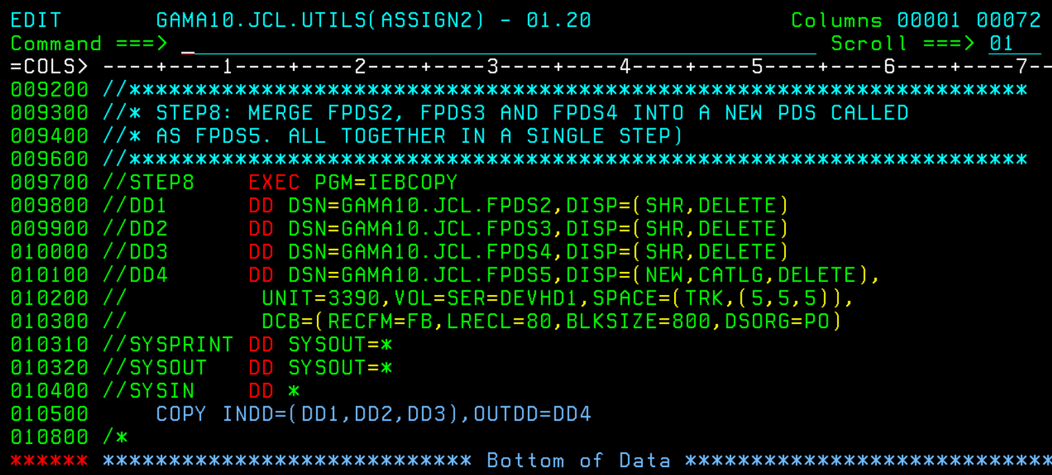

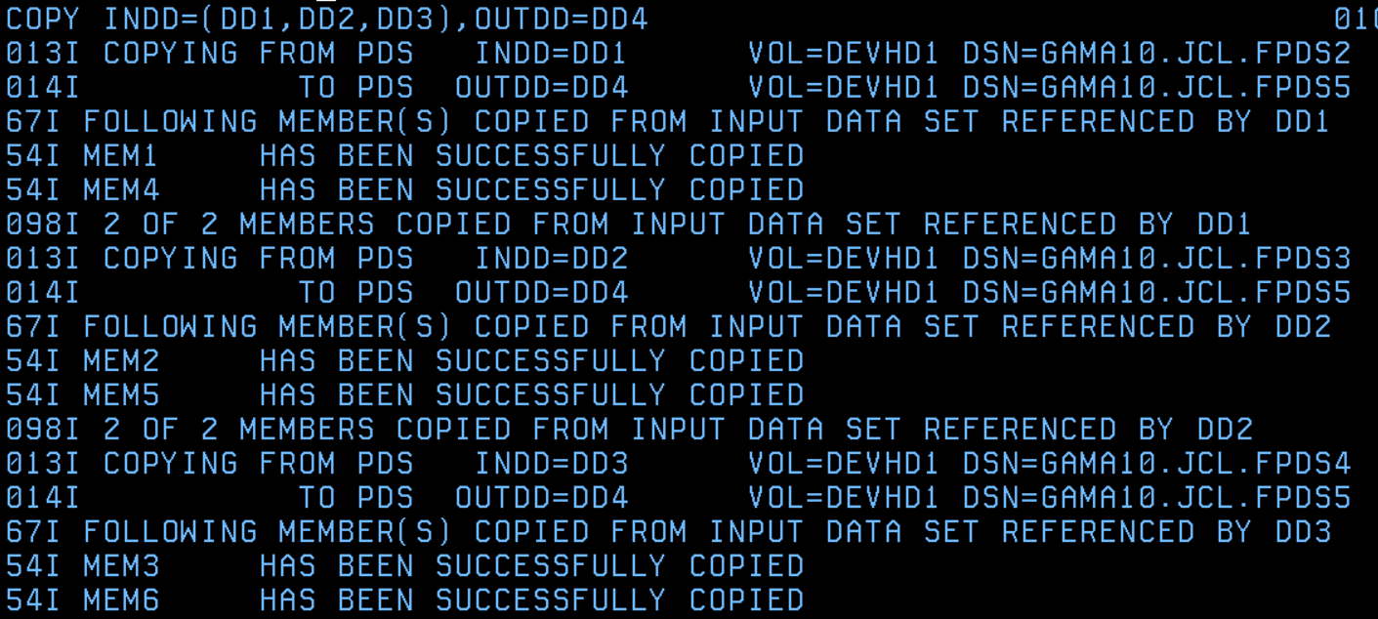

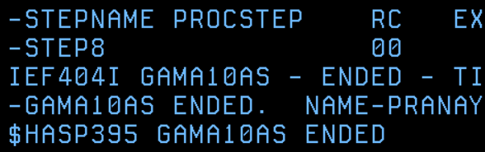

STEP9: COMPRESS FPDS5.

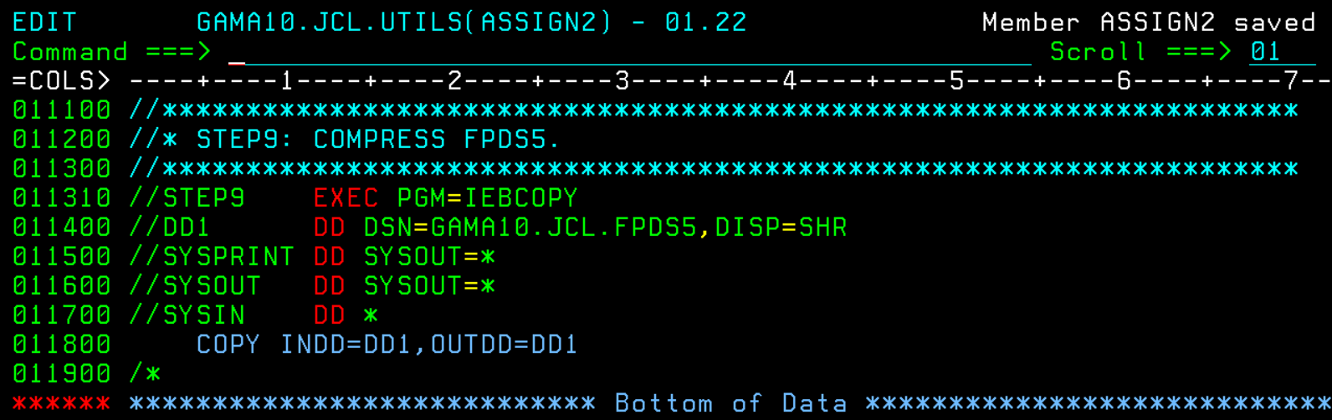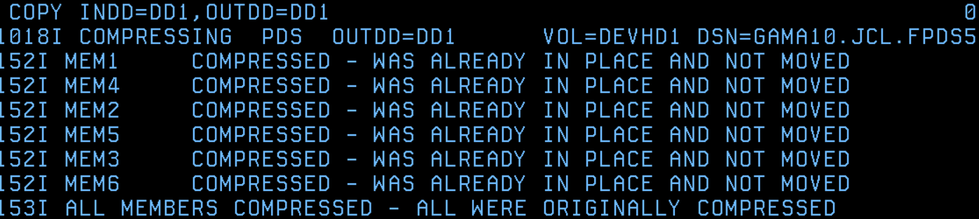

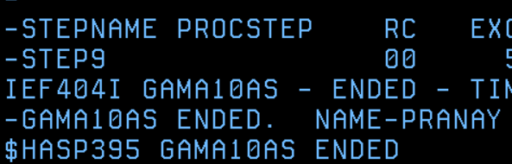

STEP10: DELETE FPDS5.

